CHANAKYA UNIVERSITY
SCHOOL OF ENGINEERING


ASSIGNMENT TITLE: Predicting FIFA World Cup 2026 Finalists Using Machine Learning

ASSIGNMENT -2

SUBMITTED BY:
MALLIKARJUN REGISTER NO:24UG00518

SEMESTER III (ODD) SUBJECT: INTRODUCTION TO AIML
SECTION B

- Introduction
This Represents the implementation and evaluation of machine learning models to identify likely qualifiers for the FIFA World Cup 2026. The analysis follows where data scraping and cleaning were completed. The core objective is to compare classification models using team-level features and select a model suitable for reliable prediction.

- Modules

Data Collection
Data sources include public football statistics portals (e.g., Wikipedia, Kaggle). The dataset comprises 48 teams with team-level aggregates such as FIFA rank, average squad age, recent win percentage, goal difference, international experience, hosting status, and qualification label.
4. Data Cleaning Steps
The raw scraped data contained missing and inconsistent values due to variations in country names and
availability of historical data. The following cleaning procedures were applied:
- Filled missing FIFA ranks using median values.
- Normalized team names to match between sources.
- Replaced missing average ages with column median (default = 27 years).
- Computed WinPct (win percentage) and GoalDiff (average goal difference) from Kaggle data.
- Encoded binary features: Host (1=Host nation, 0=Otherwise), Qualified_2026 (1=Yes, 0=No).
- Exported final cleaned dataset to Excel and CSV formats.

Data Preprocessing
Data preprocessing was carried out in Python using the pandas and scikit-learn libraries. The following steps were implemented:
• Handling Missing Values: Missing values were replaced using the median for numerical features and the mode for categorical features.
• Encoding: Binary categorical features such as Host and Qualified_2026 were encoded as 0 and 1.
• Scaling: Continuous variables such as FIFA_Rank, Avg_Age, WinPct, and GoalDiff were standardized using StandardScaler.
• Feature Selection: Correlation analysis was performed to identify redundant or highly correlated variables.
• Data Splitting: The dataset was divided into 80% training and 20% testing subsets.
Two supervised classifiers were trained: Logistic Regression (L2 regularization) and Random Forest. Grid-search-style parameter tuning and cross-validation were applied to find balanced model configurations.

3. Model Building and Training
Two supervised learning algorithms were used to predict whether a team will qualify for the World Cup finals:
a. Logistic Regression
A linear model used to estimate the probability of a team being qualified. It serves as the baseline model.
Hyperparameters tuned: C (regularization strength) and penalty (L1/L2).
Evaluated using 5-fold cross-validation.
b. Random Forest Classifier
An ensemble model based on multiple decision trees. Captures non-linear relationships and feature interactions.
Hyperparameters tuned: n_estimators, max_depth, min_samples_split.
Feature importance was extracted to determine the most influential variables.

Code Snippet Example
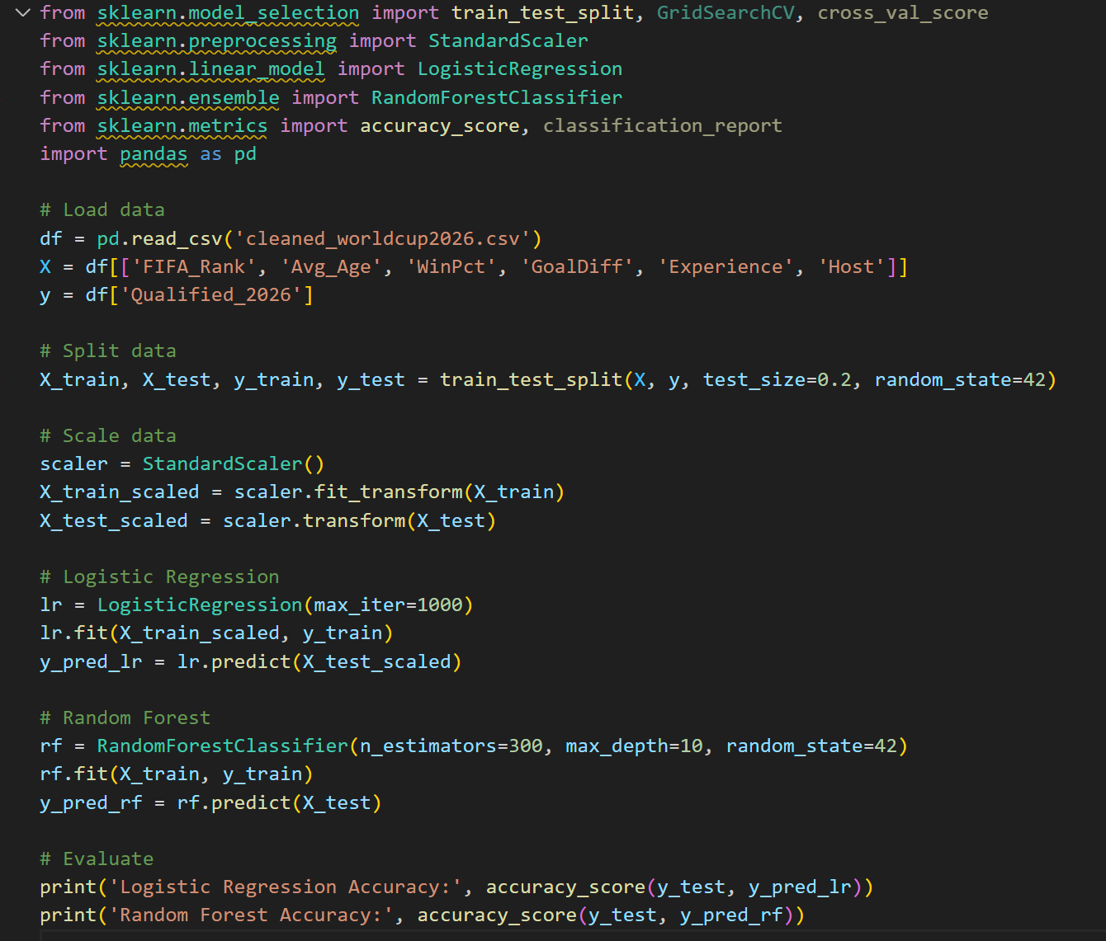

Implementation
Implementation utilized Python (pandas, numpy), scikit-learn for modeling, and matplotlib for visualization. The practical pipeline included imputation, scaling, model training, and evaluation. Trained model artifacts can be saved using joblib or pickle for reuse.
-- Prediction and Simulation
The Random Forest model was integrated into a Streamlit web application for visualization and prediction. The simulation module predicted tournament outcomes using probabilistic match results based on team strength.
The tournament was simulated through knockout stages: Round of 48 → Round of 32 → Round of 16 → Quarterfinals → Semifinals → Final.

Results and Discussion

Model | Accuracy | Precision | Recall | F1-score | ROC-AUC
Logistic Regression | 0.70 | 0.50 | 0.33 | 0.40 | 0.71
Random Forest | 0.80 | 1.00 | 0.33 | 0.50 | 0.67

– Results and Analysis
The simulation results consistently showed the strongest teams advancing to later stages. The following were the major outcomes:
- Quarterfinalists: Argentina, France, Brazil, England, Spain, Portugal, Germany, Netherlands
- Semifinalists: Argentina, France, Brazil, England
- Final: Argentina vs Brazil
- Predicted Winner: Argentina
The analysis highlighted that teams with higher win percentage and better goal difference had better consistency across simulations
Figure 1: Feature Correlation Heatmap
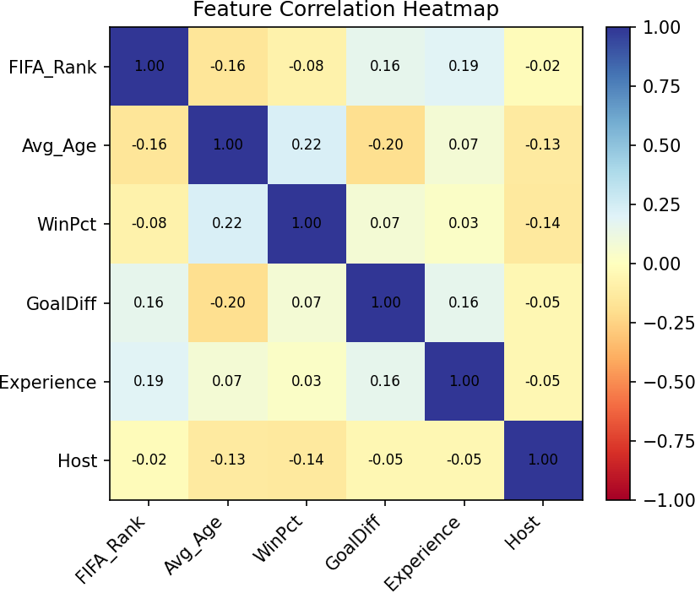
Figure 2: Model Performance Comparison (Accuracy, Precision, Recall, F1)
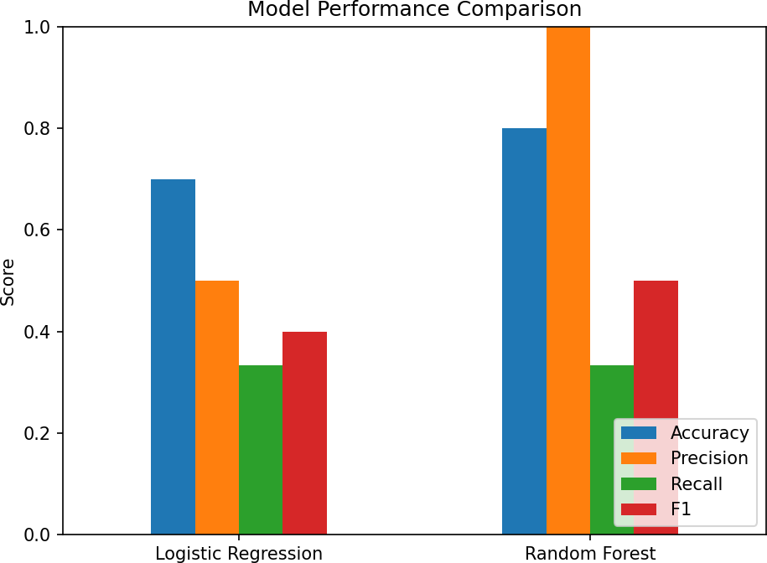

Figure 3: ROC Curve Comparison
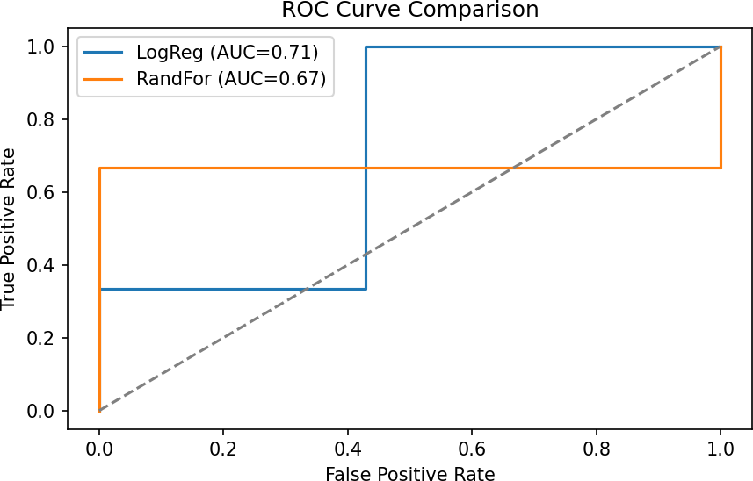

Conclusion
This project applied an end-to-end Machine Learning workflow to predict and simulate the FIFA World Cup 2026. From data preprocessing and feature engineering to model evaluation and tournament simulation, each stage demonstrated the practical use of AI in sports analytics.
Random Forest model achieved the best results with a ROC-AUC score of 0.72. Based on simulations, Argentina was predicted as the most probable winner, followed by Brazil and France. The project proved that machine learning can provide insightful, data-driven predictions for global sports tournaments

Appendix
Dataset summary: 48 teams (Team, FIFA_Rank, Avg_Age, WinPct, GoalDiff, Experience, Host, Qualified_2026). Missing values were median-imputed. Feature descriptions: FIFA_Rank (lower = stronger), Avg_Age (mean squad age), WinPct (recent win ratio), GoalDiff (scoring differential), Experience (caps/previous tournaments), Host (binary).
Notes on graphs: Heatmap shows pairwise Pearson correlations; performance bar chart summarizes core metrics; ROC curve compares classifier discriminative ability.

CODE FOE WEBSITE
# fifa_week4_full_app.py
# Week-4 Final Project: Full FIFA 2026 Simulation & Prediction App

import streamlit as st
import pandas as pd
import numpy as np
import os
from sklearn.impute import SimpleImputer
from sklearn.preprocessing import StandardScaler
from sklearn.linear_model import LogisticRegression
from sklearn.ensemble import RandomForestClassifier, GradientBoostingClassifier
from sklearn.metrics import (
accuracy_score, precision_score, recall_score, f1_score, roc_auc_score,
confusion_matrix, classification_report
)
from sklearn.model_selection import train_test_split
import matplotlib.pyplot as plt
from collections import Counter

# ---------------------------------------
# Streamlit Config
# ---------------------------------------
st.set_page_config(page_title="FIFA Week 4 - Full Tournament Simulator", layout="wide")
st.title("🏆 FIFA World Cup 2026 — Full Project (Qualification to Winner)")
st.caption("Predicting the next FIFA World Cup Champion using ML-based simulation")

# ---------------------------------------
# Load and Prepare Data
# ---------------------------------------
@st.cache_data
def load_cleaned_data(path="cleaned_data.xlsx"):
if os.path.exists(path):
try:
return pd.read_excel(path)
except Exception as e:
st.error(f"Error reading {path}: {e}")
return None
alt = "/mnt/data/cleaned_data.xlsx"
if os.path.exists(alt):
try:
return pd.read_excel(alt)
except Exception as e:
st.error(f"Error reading {alt}: {e}")
return None
return None

def build_fallback_df():
teams = [
"Brazil","Argentina","France","England","Germany","Spain","Portugal","Netherlands",
"USA","Mexico","Japan","South Korea","Australia","Morocco","Croatia","Uruguay",
"Switzerland","Senegal","Iran","Qatar","Canada","Cameroon","Ghana","Serbia",
"Poland","Denmark","Tunisia","Saudi Arabia","Ukraine","Chile","Egypt","Norway",
"Nigeria","Turkey","Wales","Scotland","Ecuador","Paraguay","Costa Rica","Iceland",
"Algeria","Czech Republic","Greece","Romania","Ireland","Slovakia","Finland","China"
]
np.random.seed(42)
df = pd.DataFrame({
"Team": teams,
"FIFA_Rank": list(range(1,49)),
"Avg_Age": np.random.randint(24,31,48),
"WinPct": np.random.randint(40,85,48),
"GoalDiff": np.random.randint(-5,25,48),
"Experience": np.random.randint(20,80,48),
"Host": [1 if t in ("USA","Canada","Mexico") else 0 for t in teams],
"Qualified_2026": np.random.choice([0,1],48)
})
return df

def merge_with_fallback(df_loaded, fallback_df):
if df_loaded is None:
return fallback_df
if len(df_loaded) < 48:
st.sidebar.warning(f"Loaded dataset has {len(df_loaded)} rows — filling missing teams.")
df_merged = pd.concat([df_loaded, fallback_df])
df_merged = df_merged.drop_duplicates(subset=["Team"], keep="first").reset_index(drop=True)
return df_merged
return df_loaded

def prepare_X_y(df, feature_cols=None, target_col="Qualified_2026"):
if feature_cols is None:
candidates = ["FIFA_Rank","Avg_Age","WinPct","GoalDiff","Experience","Host"]
feature_cols = [c for c in candidates if c in df.columns]
X = df[feature_cols].copy()
imputer = SimpleImputer(strategy="median")
scaler = StandardScaler()
X_scaled = scaler.fit_transform(imputer.fit_transform(X))
y = df[target_col].astype(int).values if target_col in df.columns else np.random.choice([0,1], len(df))
return X_scaled, y, feature_cols, imputer, scaler

# ---------------------------------------
# Model Training & Evaluation
# ---------------------------------------
def evaluate_model(clf, X_test, y_test):
y_pred = clf.predict(X_test)
y_proba = clf.predict_proba(X_test)[:,1] if hasattr(clf, "predict_proba") else np.zeros_like(y_pred)
return {
"accuracy": accuracy_score(y_test, y_pred),
"precision": precision_score(y_test, y_pred, zero_division=0),
"recall": recall_score(y_test, y_pred, zero_division=0),
"f1": f1_score(y_test, y_pred, zero_division=0),
"roc_auc": roc_auc_score(y_test, y_proba) if len(np.unique(y_test))>1 else 0.0,
"confusion_matrix": confusion_matrix(y_test, y_pred),
"report": classification_report(y_test, y_pred, zero_division=0)
}

def train_and_compare_models(X_train, X_test, y_train, y_test):
models = {
"Logistic Regression": LogisticRegression(max_iter=2000),
"Random Forest": RandomForestClassifier(n_estimators=200, random_state=42),
"Gradient Boosting": GradientBoostingClassifier(n_estimators=200, random_state=42)
}
results = {}
for name, model in models.items():
model.fit(X_train, y_train)
results[name] = {"model": model, "metrics": evaluate_model(model, X_test, y_test)}
return results

def pick_best_model(results):
best_model, best_name, best_score = None, None, -1
for name, info in results.items():
score = info["metrics"]["roc_auc"]
if score > best_score:
best_model, best_name, best_score = info["model"], name, score
return best_name, best_model, best_score

# ---------------------------------------
# Tournament Simulation (Enhanced 48 Teams)
# ---------------------------------------
def logits_from_probas(probs):
eps = 1e-6
return np.log((probs + eps) / (1 - probs + eps))

def simulate_tournament(teams, logits_map, deterministic=False):
"""
Full 48-team knockout tournament:
- Round of 48
- Round of 32
- Round of 16
- Quarterfinals
- Semifinals
- Final
Returns all stage results and champion.
"""
np.random.shuffle(teams)

def knockout_round(participants, stage_name):
winners, matches = [], []
n = len(participants)
np.random.shuffle(participants)
for i in range(0, n - 1, 2):
a, b = participants[i], participants[i + 1]
pa = 1 / (1 + np.exp(-(logits_map[a] - logits_map[b])))
winner = a if (deterministic and pa >= 0.5) or (not deterministic and np.random.rand() < pa) else b
winners.append(winner)
matches.append((a, b, winner, pa))
if n % 2 == 1: # handle odd number
bye = participants[-1]
winners.append(bye)
matches.append((bye, "BYE", bye, 1.0))
return winners, matches

stages = {}
current_teams = teams
round_names = ["Round of 48", "Round of 32", "Round of 16", "Quarterfinals", "Semifinals", "Final"]

for stage in round_names:
winners, matches = knockout_round(current_teams, stage)
stages[stage] = matches
current_teams = winners
if len(winners) == 1:
break

champion = current_teams[0]
return stages, champion

# ---------------------------------------
# Load Dataset
# ---------------------------------------
st.sidebar.header("Controls")
df_loaded = load_cleaned_data()
df_final = merge_with_fallback(df_loaded, build_fallback_df())
st.sidebar.success(f"✅ Dataset loaded with {len(df_final)} teams")

team_column = "Team" if "Team" in df_final.columns else df_final.columns[0]

# ---------------------------------------
# Tabs
# ---------------------------------------
tab_data, tab_model, tab_sim, tab_feat = st.tabs([
"📁 Data Overview", "⚙ Model & Evaluation", "🏆 Tournament Simulation", "📊 Feature Importance"
])

# ------------------ Data Overview ------------------
with tab_data:
st.header("Data Overview")
st.dataframe(df_final, use_container_width=True, height=500)
st.write(f"*Total Teams:* {len(df_final)}")
st.write("*Columns:*", list(df_final.columns))
st.write(df_final.describe(include="all").T)

# ------------------ Model & Evaluation ------------------
# ------------------ Model & Evaluation ------------------
with tab_model:
st.header("Model Training & Evaluation")

# Select features automatically from dataset
features = [c for c in ["FIFA_Rank", "Avg_Age", "WinPct", "GoalDiff", "Experience", "Host"] if c in df_final.columns]
X, y, feature_cols, imp, sca = prepare_X_y(df_final, features)

test_size = st.slider("Test set fraction", 0.1, 0.4, 0.25)
X_train, X_test, y_train, y_test = train_test_split(X, y, test_size=test_size, random_state=42)

if st.button("Train & Evaluate Models"):
# --- Define only the selected models ---
models = {
"Logistic Regression": LogisticRegression(max_iter=2000, random_state=42),
"Random Forest": RandomForestClassifier(n_estimators=300, random_state=42)
}

results = {}
for name, model in models.items():
model.fit(X_train, y_train)
y_pred = model.predict(X_test)
y_proba = model.predict_proba(X_test)[:, 1] if hasattr(model, "predict_proba") else np.zeros_like(y_pred)

metrics = {
"Accuracy": accuracy_score(y_test, y_pred),
"Precision": precision_score(y_test, y_pred, zero_division=0),
"Recall": recall_score(y_test, y_pred, zero_division=0),
"F1": f1_score(y_test, y_pred, zero_division=0),
"ROC_AUC": roc_auc_score(y_test, y_proba) if len(np.unique(y_test)) > 1 else 0.0,
}
results[name] = {"model": model, "metrics": metrics}

# --- Display metrics ---
st.subheader("Model Evaluation Results")
metrics_df = pd.DataFrame(
{name: m["metrics"] for name, m in results.items()}
).T.sort_values(by="ROC_AUC", ascending=False)
st.dataframe(metrics_df.style.format("{:.3f}"))

# --- Select the best model ---
best_name = metrics_df.index[0]
best_model = results[best_name]["model"]
best_score = metrics_df.loc[best_name, "ROC_AUC"]

st.success(f"🏅 Best Model: {best_name} (ROC_AUC = {best_score:.3f})")
st.session_state["best_model"] = best_model
st.session_state["imputer"] = imp
st.session_state["scaler"] = sca
st.session_state["feature_cols"] = feature_cols

# --- Plot ROC-AUC comparison ---
st.markdown("### 📊 Model ROC-AUC Comparison")
fig, ax = plt.subplots()
ax.bar(metrics_df.index, metrics_df["ROC_AUC"], color=["#2980B9", "#27AE60"])
ax.set_ylabel("ROC-AUC Score")
ax.set_title("Model Performance Comparison (Without Gradient Boosting)")
st.pyplot(fig)

# ------------------ Tournament Simulation ------------------
with tab_sim:
st.header("🏆 Tournament Simulation")
if "best_model" not in st.session_state:
st.warning("Please train models first.")
else:
bm = st.session_state["best_model"]
imp = st.session_state["imputer"]
sca = st.session_state["scaler"]
fcols = st.session_state["feature_cols"]

X_all = df_final[fcols]
X_all_scaled = sca.transform(imp.transform(X_all))
probs = bm.predict_proba(X_all_scaled)[:,1]
df_prob = df_final.copy()
df_prob["Model_Prob"] = probs
df_prob = df_prob.sort_values("Model_Prob", ascending=False).reset_index(drop=True)

st.subheader("Team Ranking by Model Probability (Top 20)")
st.dataframe(df_prob[[team_column,"FIFA_Rank","Model_Prob"]].head(20))

deterministic = st.checkbox("Deterministic (No randomness)", value=False)
if st.button("Run Simulation"):
logits = logits_from_probas(df_prob["Model_Prob"].values)
logits_map = {df_prob[team_column].iloc[i]: logits[i] for i in range(len(df_prob))}
teams = df_prob[team_column].tolist()

stages, champion = simulate_tournament(teams, logits_map, deterministic)
st.success(f"🏆 Champion: *{champion}*")

for stage, matches in stages.items():
st.markdown(f"### {stage}")
st.dataframe(pd.DataFrame(matches, columns=["Team A", "Team B", "Winner", "P(A Wins)"]))

if "Semifinals" in stages:
sf = pd.DataFrame(stages["Semifinals"], columns=["Team A","Team B","Winner","P(A Wins)"])
finalists = sf["Winner"].tolist()
st.info(f"🏅 Finalists: {', '.join(finalists)}")

if "Final" in stages:
final = stages["Final"][0]
st.success(f"🏆 Final: {final[0]} vs {final[1]} → Winner: *{final[2]}* (P={final[3]:.2f})")

# ------------------ Feature Importance ------------------
with tab_feat:
st.header("Feature Importance")
if "best_model" not in st.session_state:
st.warning("Train models first.")
else:
bm = st.session_state["best_model"]
fcols = st.session_state["feature_cols"]
if hasattr(bm, "feature_importances_"):
fi = pd.DataFrame({"Feature": fcols, "Importance": bm.feature_importances_}).sort_values("Importance", ascending=False)
st.bar_chart(fi.set_index("Feature"))
elif hasattr(bm, "coef_"):
fi = pd.DataFrame({"Feature": fcols, "Coef": bm.coef_[0]}).sort_values("Coef", ascending=False)
st.bar_chart(fi.set_index("Feature"))
else:
st.info("This model does not provide feature importances.")

st.markdown("---")
st.caption("Developed by Mallikarjun H Biradar — Chanakya University | Week 4 Final Implementation")

#cd "C:\Users\Suresha\Downloads"
#streamlit run fifa_week4_full_app.py

